CS 4354 Database Systems
Assignment 1

Name:____Chen Zhang_________________

Question 1. (8 pts)

Consider the following set of requirements for a university database that is used to keep track of students' transcripts.

(a) The university keeps track of each student's name, student number, social security number, current address and phone, birthdate, sex, class (freshman, sophomore, ..., graduate), major department, minor department (if any). Each student can have only one major at a time, but can have several minor. Some user applications need to refer to the city, state, and zip of the student's current address, and to the student's last name. Both social security number and student number have unique values for each student.

(b) Each department is described by a name, department code, office number, office phone, and college. The department also records the derived value for the number of students who majored in the department and the number of students who minored in the department. Both name and code have unique values for each department.

(c) Each course has a course name, description, course number, number of semester hours, level, and offering department. The value of course number is unique for each course.

(d) Each section has an instructor, semester, year, course, and section number. The section number distinguishes different sections of the same course that are taught during the same semester/year; its values are 1, 2, 3, ...; up to the number of sections taught during each semester (therefore, section number is NOT unique).

(e) A grade report has a student, section, letter grade, and numeric grade (0, 1, 2, 3, 4 for F, D, C, B, A, respectively).

Design an ER schema for this application, and draw an ER diagram for that schema.
Specify key attributes of each entity type and structural constraints on each relationship type. Note any unspecified requirements, and make appropriate assumptions to make the specification complete (including all cardinal ratio and total/partial participation).

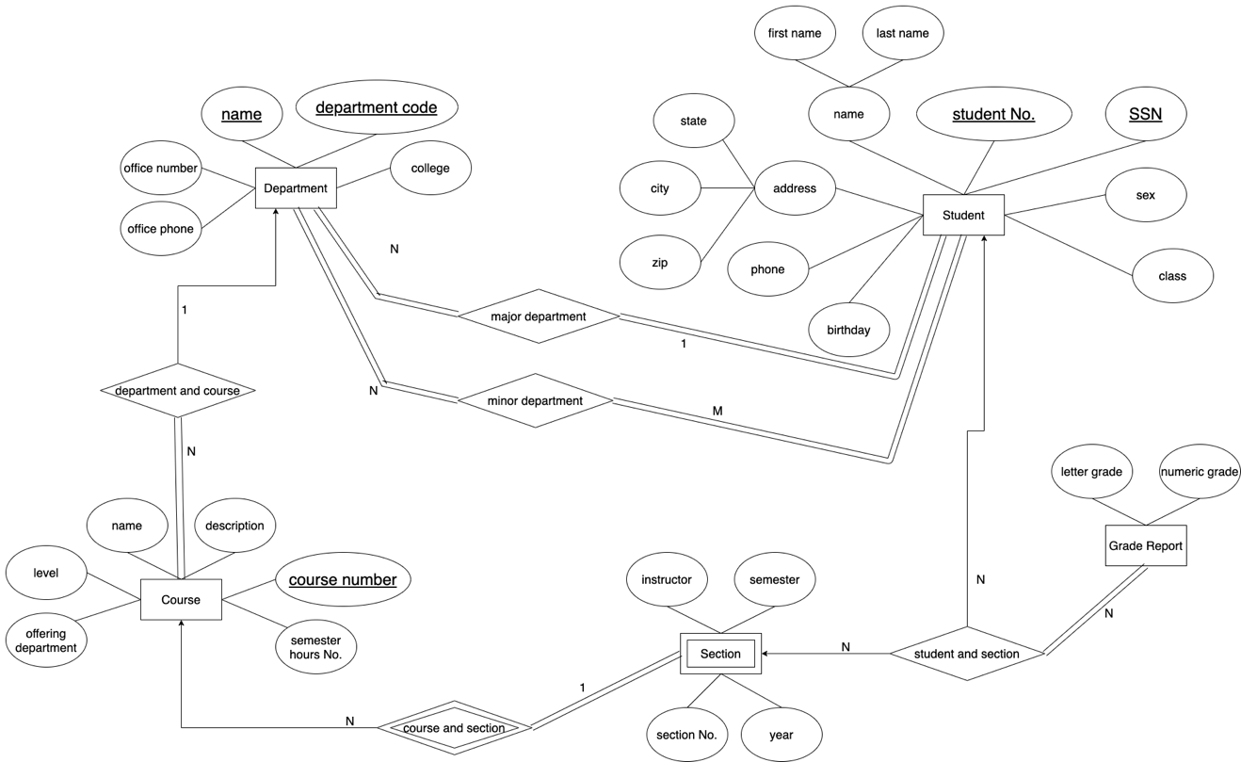

Question 2 (2 pts)
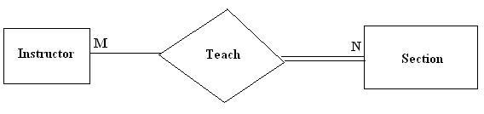
Please explain the meaning of “teach relationship” in the figure. (Including all cardinal ratios and total/partial participation).

Answer: One instructor can teach several sections and one section can have multiple instructors, also every instructor must have at least one section to teach and every section must have at least one instructor to teach.

